**AsyncTask**

Исходный код проекта:

<https://github.com/verkhoumov/AndroidLabs/tree/master/AsyncTask>

Скриншоты экрана:

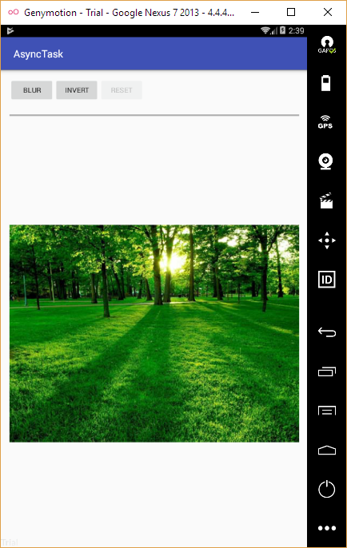

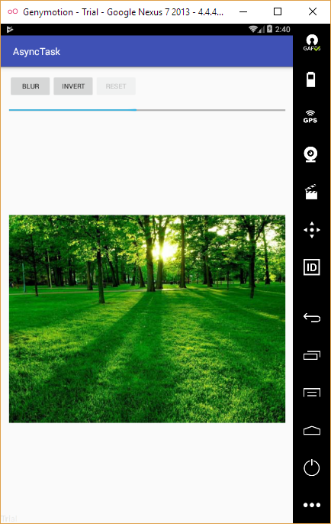

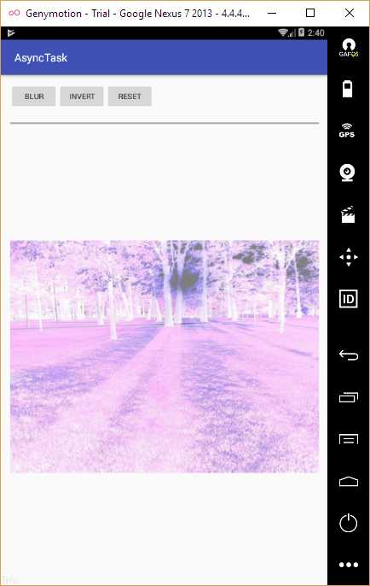

Исходный код.

MainActivity.java:

1. **package** ru.verkhoumov.asynctask;
3. **import** android.content.Intent;
4. **import** android.graphics.Bitmap;
5. **import** android.graphics.drawable.BitmapDrawable;
6. **import** android.os.AsyncTask;
7. **import** android.support.v7.app.AppCompatActivity;
8. **import** android.os.Bundle;
9. **import** android.view.View;
10. **import** android.widget.Button;
11. **import** android.widget.ImageView;
12. **import** android.widget.ProgressBar;
14. **public** **class** MainActivity **extends** AppCompatActivity {
15. **private** ProgressBar progressBar;
17. @Override
18. **protected** **void** onCreate(Bundle savedInstanceState) {
19. **super**.onCreate(savedInstanceState);
20. setContentView(R.layout.activity_main);
22. *// Создаём ссылку на элемент прогресс бара.*
23. progressBar = (ProgressBar) findViewById(R.id.progressBar);
24. }
26. **public** **void** doBlur(View view) {
27. BlurImageTask task = **new** BlurImageTask();
28. ImageView imageView = (ImageView) findViewById(R.id.imageView);
29. Bitmap bitmap = ((BitmapDrawable) imageView.getDrawable()).getBitmap();
30. task.execute(bitmap);
31. }
33. **public** **void** doInvert(View view) {
34. InvertImageTask task = **new** InvertImageTask();
35. ImageView imageView = (ImageView) findViewById(R.id.imageView);
36. Bitmap bitmap = ((BitmapDrawable) imageView.getDrawable()).getBitmap();
37. task.execute(bitmap);
38. }
40. **public** **void** doReset(View view) {
41. ImageView imageView = (ImageView) findViewById(R.id.imageView);
42. imageView.setImageResource(R.drawable.nature);
44. *// Деактивируем кнопку сброса.*
45. disabledResetButton();
46. }
48. **public** **void** enabledResetButton() {
49. Button button = (Button) findViewById(R.id.resetBtn);
51. **if** (!button.isEnabled()) {
52. button.setEnabled(**true**);
53. }
54. }
56. **public** **void** disabledResetButton() {
57. Button button = (Button) findViewById(R.id.resetBtn);
59. **if** (button.isEnabled()) {
60. button.setEnabled(**false**);
61. }
62. }
64. **private** **class** BlurImageTask **extends** AsyncTask<Bitmap, Integer, Bitmap> {
65. **protected** Bitmap doInBackground(Bitmap... bitmap) {
66. Bitmap input = bitmap[0];
67. Bitmap result = input.copy(input.getConfig(), **true**);
69. **int** width = input.getWidth();
70. **int** height = input.getHeight();
71. **int** level = 7;
73. **for** (**int** i = 0; i < height; i++) {
74. **for** (**int** j = 0; j < width; j++) {
75. **int** pixel = input.getPixel(j, i);
76. **int** a = pixel & 0xff000000;
77. **int** r = (pixel >> 16) & 0xff;
78. **int** g = (pixel >> 8) & 0xff;
79. **int** b = pixel & 0xff;
81. r = (r + level) / 2;
82. g = (g + level) / 2;
83. b = (b + level) / 2;
85. **int** gray = a | (r << 16) | (g << 8) | b;
87. result.setPixel(j, i, gray);
88. }
90. **int** progress = 100 * (i + 1) / height;
92. publishProgress(progress);
93. }
95. **return** result;
96. }
98. **protected** **void** onProgressUpdate(Integer... values) {
99. progressBar.setProgress(values[0]);
100. }
102. **protected** **void** onPostExecute(Bitmap result) {
103. *// Обновляем изображение.*
104. ImageView imageView = (ImageView) findViewById(R.id.imageView);
105. imageView.setImageBitmap(result);
107. *// По окочанию выполнения операции надо обнулить прогресс бар.*
108. progressBar.setProgress(0);
110. *// Активируем кнопку сброса.*
111. enabledResetButton();
112. }
113. }
115. **private** **class** InvertImageTask **extends** AsyncTask<Bitmap, Integer, Bitmap> {
116. **protected** Bitmap doInBackground(Bitmap... bitmap) {
117. Bitmap input = bitmap[0];
118. Bitmap result = input.copy(input.getConfig(), **true**);
120. **int** width = input.getWidth();
121. **int** height = input.getHeight();
123. **for** (**int** i = 0; i < height; i++) {
124. **for** (**int** j = 0; j < width; j++) {
125. **int** pixel = input.getPixel(j, i);
126. **int** a = pixel & 0xff000000;
128. a = a | (~pixel & 0x00ffffff);
130. result.setPixel(j, i, a);
131. }
133. **int** progress = 100 * (i + 1) / height;
135. publishProgress(progress);
136. }
138. **return** result;
139. }
141. **protected** **void** onProgressUpdate(Integer... values) {
142. progressBar.setProgress(values[0]);
143. }
145. **protected** **void** onPostExecute(Bitmap result) {
146. *// Обновляем изображение.*
147. ImageView imageView = (ImageView) findViewById(R.id.imageView);
148. imageView.setImageBitmap(result);
150. *// По окочанию выполнения операции надо обнулить прогресс бар.*
151. progressBar.setProgress(0);
153. *// Активируем кнопку сброса.*
154. enabledResetButton();
155. }
156. }
157. }

activity_main.xml:

1. **<?xml** version="1.0" encoding="utf-8"**?>**
2. **<LinearLayout** xmlns:android="http://schemas.android.com/apk/res/android"
3. xmlns:tools="http://schemas.android.com/tools"
4. android:layout_width="match_parent"
5. android:layout_height="match_parent"
6. android:paddingBottom="@dimen/activity_vertical_margin"
7. android:paddingLeft="@dimen/activity_horizontal_margin"
8. android:paddingRight="@dimen/activity_horizontal_margin"
9. android:paddingTop="@dimen/activity_vertical_margin"
10. tools:context="ru.verkhoumov.asynctask.MainActivity"
11. android:orientation="vertical"**>**
13. **<LinearLayout**
14. android:orientation="horizontal"
15. android:layout_width="match_parent"
16. android:layout_height="wrap_content"**>**
17. **<Button**
18. android:layout_width="wrap_content"
19. android:layout_height="wrap_content"
20. android:text="@string/blurBtn"
21. android:onClick="doBlur" **/>**
23. **<Button**
24. android:layout_width="wrap_content"
25. android:layout_height="wrap_content"
26. android:text="@string/invertBtn"
27. android:onClick="doInvert" **/>**
29. **<Button**
30. android:layout_width="wrap_content"
31. android:layout_height="wrap_content"
32. android:text="@string/resetBtn"
33. android:onClick="doReset"
34. android:enabled="false"
35. android:id="@+id/resetBtn" **/>**
36. **</LinearLayout>**
38. **<ProgressBar**
39. style="?android:attr/progressBarStyleHorizontal"
40. android:layout_width="match_parent"
41. android:layout_height="50dp"
42. android:id="@+id/progressBar" **/>**
44. **<ImageView**
45. android:layout_width="match_parent"
46. android:layout_height="match_parent"
47. android:id="@+id/imageView"
48. android:src="@drawable/nature" **/>**
49. **</LinearLayout>**

strings.xml:

1. **<resources>**
2. **<string** name="app_name"**>**AsyncTask**</string>**
3. **<string** name="blurBtn"**>**BLUR**</string>**
4. **<string** name="invertBtn"**>**INVERT**</string>**
5. **<string** name="resetBtn"**>**RESET**</string>**
6. **</resources>**